***MOVIES DATA ANALYSIS***

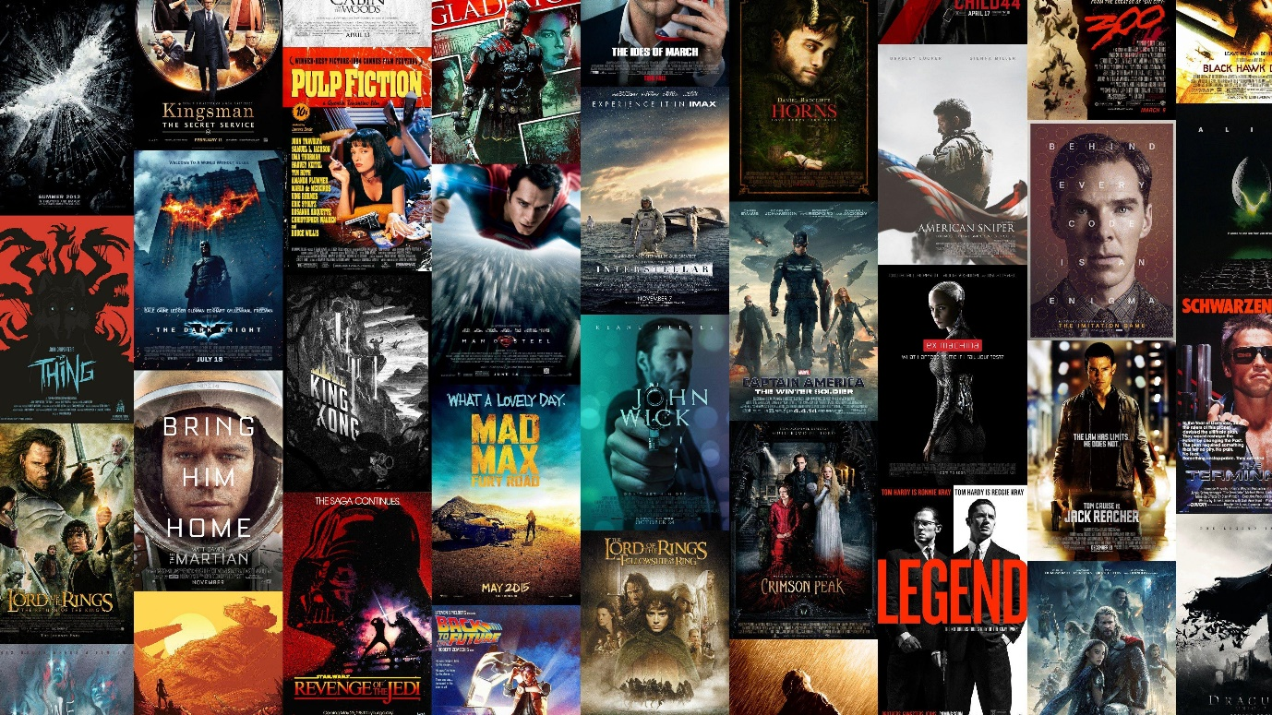

***SYNOPSIS***

***PROJECT OBJECTIVES***

*The primary objective of this project is to perform an in-depth analysis of a movie dataset to uncover key insights, trends, and patterns. The dataset contains information about various movie attributes, including title, genre, release year, ratings, and more. By leveraging Python for data cleaning and creating a recommendation system, and using Power BI for visualization, the project aims to provide a clear understanding of movie preferences and trends.*

*One of the goals is to create a recommendation system that can suggest movies based on user ratings and preferences. Additionally, the project aims to explore relationships between different variables, such as genre popularity over time and the impact of movie ratings on user engagement. These insights will help stakeholders understand movie preferences and trends in the industry.*

***DATA COLLECTION***

*The dataset for this project was sourced from Kaggle, a platform widely used for data science competitions and datasets. The dataset contains information on movies, including key attributes such as title, release year, rating, genre, and user ratings. This raw data was obtained to allow for comprehensive analysis, ranging from data cleaning to building predictive models.*

*Since the dataset contained some inconsistencies, missing values, and duplicate entries, a significant amount of preprocessing was required before it could be used for meaningful analysis and visualization. This step was critical to ensuring the reliability and accuracy of the subsequent analyses and visualizations.*

***DATA ANALYSIS PROCESS***

*The data analysis process started with data cleaning, which involved handling missing values, duplicates, and standardizing the format of key fields like genre and ratings. This was achieved using Python libraries such as Pandas and NumPy, which allowed efficient data manipulation. The cleaned dataset provided the foundation for further analysis.*

*Once the data was cleaned, the analysis proceeded with the creation of visualizations in Power BI. These visualizations helped to showcase key insights, such as the distribution of movies across different genres and their ratings. In addition, a recommendation system was developed in Python using techniques like collaborative filtering to suggest movies based on users' viewing patterns and ratings. The combination of Python and Power BI enabled both in-depth analysis and interactive data presentation.*

***IMPORTANCE***

*This project is important as it provides a detailed analysis of movie data, which can inform decision-makers in the film industry about user preferences, popular genres, and rating trends. In an era where content platforms like Netflix rely heavily on user engagement and satisfaction, understanding what appeals to viewers is vital.*

*By analyzing movie data and building a recommendation system, this project not only highlights key trends but also demonstrates how data-driven insights can help improve user satisfaction and movie offerings. These findings can be used by studios, streaming services, and marketers to curate content that aligns with audience preferences.*

***SCOPE***

*The scope of this project is broad, encompassing various aspects of data analysis, from cleaning the raw dataset to creating advanced visualizations and a recommendation system. This project goes beyond simple descriptive analysis by providing predictive capabilities through the recommendation engine. The visualizations in Power BI allow stakeholders to explore key metrics interactively, ensuring actionable insights.*

*In the future, this project can be expanded to include more advanced machine learning techniques, such as content-based recommendation systems or sentiment analysis of user reviews. Additionally, the scope may include further segmentation of the data by factors like region or age demographics to provide more targeted recommendations.*

***SOFTWARE***

*The project was conducted using several key software tools, each playing a critical role in different stages of the analysis:*

* ***Jupyter Notebook****: Used for data cleaning and preprocessing. Python libraries such as pandas, NumPy, and matplotlib were instrumental in transforming the raw data into a usable format.*
* ***Excel Workbook****: Excel was used for initial data exploration and basic cleaning, especially for handling smaller subsets of the data and ensuring proper formatting.*
* ***Power BI****: Power BI was used for data visualization and dashboard creation. Its interactive features made it an ideal choice for presenting the analysis in a way that stakeholders could easily interpret and explore further.*
* ***Python Packages and Libraries****: The project relied on Python's robust ecosystem for data science, with key libraries including pandas for data manipulation, NumPy for numerical operations, and matplotlib for basic visualizations.*

1. ***HARDWARE***

***Device name:*** *Game on.*

***Processor:*** *12th Gen Intel(R) Core (TM) i7-12700H 2.30 GHz*

***Installed RAM:*** *16.0 GB (15.6 GB usable)*

***Device ID:*** *244AA89F-3C2F-4D62-901D-3F0BFBB6F359*

***Product ID:*** *00342-43365-13608-AAOEM*

***System type:*** *64-bit operating system, x64-based processor*

***INTRODUCTION***

***PROJECT OVERVIEW***

*The Movies Data Analysis project aims to explore a dataset of movies to uncover trends, patterns, and insights that could influence decision-making in the entertainment industry. With the explosion of content streaming services, understanding the dynamics of movie releases, genres, ratings, and popularity is crucial. This analysis leverages data cleaning, visualization, and recommendation techniques to extract meaningful insights from the dataset.*

*Through this project, we will explore how movie trends have evolved over time, assess the distribution of movies across genres and regions, and utilize advanced algorithms to recommend movies based on user preferences. By integrating tools like Python for data cleaning and manipulation and Power BI for visualization, the project provides a comprehensive view of the movie industry and its evolving landscape.*

***Background***

*Movies continue to be one of the most popular forms of entertainment worldwide. With the rise of digital platforms, a massive influx of new releases is available, leading to an overload of content for consumers. Platforms like Netflix, Hulu, and Amazon Prime have made it easier than ever for users to access films from all over the world. However, this diversity creates the need for personalized recommendations to assist viewers in finding movies that suit their tastes.*

*Data science has emerged as an essential tool in this scenario, helping businesses analyze large datasets to extract valuable insights about consumer preferences. The dataset for this project was sourced from Kaggle and has undergone rigorous cleaning and transformation to ensure that the analysis performed will yield accurate results.*

***Objectives***

*Analysis of Movie Data:*

* *Genre Popularity Analysis: The project aims to examine how various genres are distributed across different regions and over time, identifying trends such as the rising popularity of certain genres in specific countries or among specific demographics.*
* *Country-Specific Trends: An important objective is to analyze which countries dominate the production of movies and how their outputs differ by genre, release year, or rating. This helps to understand global movie production patterns and the cultural influences on cinema.*
* *Time-Series Analysis: Another focus is on how movie releases and trends evolve over time. By analyzing movie release years, the project can provide insights into which periods saw spikes in specific genres or regions.*
* *Rating and Audience Reception: Analyzing the relationship between movie ratings (IMDb scores, content ratings) and the success of those movies is key to understanding which factors contribute most to audience satisfaction. This could help identify patterns in movies with high viewership or engagement.*

***Building a Recommendation System:***

* ***Collaborative Filtering:*** *A key goal is to develop a recommendation system that uses collaborative filtering to suggest movies based on user ratings and preferences, identifying patterns in how different users rate similar content.*
* ***Content-Based Filtering:*** *The recommendation system will also use content-based filtering to suggest movies based on specific attributes, such as genre, cast, and director, tailoring suggestions to match the user's viewing habits.*
* ***Hybrid Approach:*** *By combining collaborative filtering and content-based filtering, the project aims to create a hybrid recommendation model that can leverage the strengths of both approaches to enhance prediction accuracy.*

**Personalization for Different User Groups:** The recommendation system will personalize suggestions based on various demographic factors, such as age or geographic location, helping to recommend culturally relevant and age-appropriate content.

***Scope of the Project***

*The scope of this project is centered around a comprehensive analysis of a movie dataset, focusing on key attributes such as genre, release year, ratings, and other factors that contribute to understanding movie trends and patterns. The project is structured to provide actionable insights and a personalized recommendation system. Below is a detailed explanation of the scope:*

1. ***Data Cleaning and Preprocessing:***
   * *The first step involves cleaning the dataset to ensure accuracy and consistency. This includes:*
     + *Handling missing values by using techniques such as filling in with mean values or removing records with significant gaps.*
     + *Standardizing data formats, such as ensuring consistency in date formats, upper/lower case for text data, and proper categorization of variables like genres and ratings.*
     + *Removing duplicate entries and irrelevant data points to maintain the integrity of the dataset.*

***Data Visualization:***

* *Once the dataset is cleaned, the next step is to create insightful visualizations using Power BI to represent key trends and patterns. These visualizations will include:*
  + ***Genre Distribution:*** *Charts that display the popularity of different genres over time and across regions, helping to identify which types of movies dominate the market.*
  + ***Release Year Trends:*** *Time-series visualizations that show trends in movie production over the years, including peaks in certain periods or a rise in specific genres during particular eras.*
  + ***Geographic Trends:*** *Visualizations that map the production of movies by country, revealing which countries are key players in the global movie industry.*

***Recommendation System Development:***

* *A major component of this project is the development of a personalized recommendation system, which will be built using two main techniques:*
  + ***Collaborative Filtering:*** *This method will suggest movies based on user ratings, leveraging the idea that users who liked similar movies will likely enjoy other similar ones. It involves finding patterns in user ratings to recommend movies based on collective preferences.*
  + ***Content-Based Filtering:*** *In this approach, the recommendation system will suggest movies based on the attributes of the movies themselves, such as genre, director, or cast. This system uses the movie's features to find similar content that aligns with the user’s interests.*
  + ***Hybrid Approach:*** *The project aims to combine collaborative filtering with content-based filtering to create a hybrid recommendation model that enhances prediction accuracy by using the strengths of both methods.*

***Exploratory Data Analysis (EDA):***

* *The project will include a deep dive into various exploratory data analysis techniques to identify hidden patterns and relationships between different movie attributes. This may include:*
  + *Analyzing the correlation between a movie's attributes (e.g., cast, director) and its success in terms of ratings or viewership.*
  + *Investigating how different factors such as region, genre, or release year affect a movie's performance.*

***Inclusions***

1. ***Analysis of Movie Genres:***
   * *The project will provide an in-depth analysis of movie genres to understand which genres dominate the movie industry. The analysis will explore:*
     + ***Popularity by Region:*** *Identifying the most popular genres in different parts of the world, for example, whether action movies are more popular in certain regions while dramas perform better in others.*
     + ***Genre Trends Over Time:*** *Investigating how the popularity of specific genres has evolved over the years. For instance, has there been a surge in sci-fi movies in recent years, or are genres like romance seeing a decline?*
2. ***Examination of Movie Ratings and Their Influence on Viewership:***

* *The project will analyze how movie ratings (e.g., IMDb scores, age-based content ratings like "PG-13" or "R") impact viewership and audience reception. This analysis includes:*
  + ***Correlation Between Ratings and Popularity:*** *Identifying whether higher-rated movies (in terms of critical or audience scores) tend to have higher viewership or engagement. This can help understand how ratings influence user preferences.*

1. ***Time-Series Analysis of Movie Releases:***

* *This project will conduct a time-series analysis to identify trends in movie releases over the years, with a focus on:*
  + ***Annual Movie Production Trends:*** *Analyzing how the number of movie releases has changed over the years. For example, has there been a significant increase in movie production in the 2000s or a dip during specific periods?*
  + ***Seasonal Trends:*** *Identifying whether certain times of the year (e.g., summer or holiday seasons) tend to have more releases or are associated with the release of specific types of movies (e.g., blockbusters vs. indie films).*

***Exclusions***

1. ***No Detailed Analysis of Individual User Behavior:***
   * *The project will not delve into the specifics of how individual users interact with movies. While the recommendation system will provide content-based suggestions, it will not include:*
     + ***User-Specific Data:*** *No data on individual viewing habits, such as how many times a user watched a particular movie or their personal ratings for different movies, will be analyzed.*
     + ***User Clustering:*** *Techniques such as user segmentation based on viewing patterns (e.g., frequent watchers of a particular genre) will not be part of this analysis.*
2. ***No Study of Movie Financial Data:***
   * *Financial aspects such as box-office earnings, movie budgets, or profitability are excluded from the scope of this project. Specifically:*
     + ***Revenue and Profits:*** *The project will not analyze how much money each movie made globally or in specific markets, nor will it study the relationship between budgets and returns.*
     + ***Economic Impact:*** *While the project focuses on ratings and popularity, it will not explore how financial performance influences movie production or trends.*
3. ***No Qualitative Data Such as User Reviews and Comments:***
   * *The analysis does not include qualitative feedback from users, such as:*
     + ***User Reviews:*** *Textual reviews or comments left by users on platforms like IMDb or Rotten Tomatoes will not be included in the analysis. This data is often valuable for sentiment analysis, but is beyond the scope of this project.*
     + ***Audience Sentiment Analysis:*** *The project will not delve into understanding how people feel about the movies through comments, opinions, or textual data from forums or social media.*

***TECHNOLOGY:***

*The project makes use of the Python programming language for data cleaning and manipulation. Python’s rich ecosystem of libraries such as pandas and NumPy allows for efficient handling of large datasets. The second major tool used in this project is Power BI, a powerful business analytics tool that helps visualize the data.*

*Python is instrumental in cleaning and transforming the dataset, handling missing values, and preparing the data for analysis. Power BI is used to generate interactive visualizations, making complex data trends easily accessible for stakeholders.*

***Python***

1. ***Reading the Movie Dataset and Preprocessing the Data:***
   * *Python, with the help of libraries like* ***pandas****, is used to load the dataset into a structured format (DataFrame), which allows for easy manipulation and analysis. Preprocessing steps ensure the dataset is clean and ready for analysis.*
2. ***Cleaning Missing Values and Standardizing Formats:***
   * *Missing values in the dataset are handled using methods like replacing them with appropriate statistics (mean, mode) or dropping incomplete records. Python is also used to standardize formats, such as ensuring consistent date formats or case consistency in text data.*
3. ***Handling String Manipulations:***
   * *Python string functions are used to extract and manipulate key attributes such as movie titles, genres, or director names. For example, extracting the release year from a date or converting genres into standardized categories.*
4. ***Leveraging Libraries Like pandas and NumPy for Data Manipulation:***
   * ***pandas*** *is employed to perform tasks such as filtering, sorting, and transforming the data, while* ***NumPy*** *is used for more complex numerical operations and calculations on large arrays or matrices of data.*
5. ***Implementing Filtering and Sorting Functions:***
   * *Python is used to filter the dataset based on specific criteria, such as selecting movies from certain genres or years. Sorting operations allow the data to be ordered by attributes like ratings, release year, or popularity.*
6. ***Converting Categorical Variables into Numerical Forms:***
   * *Categorical columns (e.g., genre, ratings) are converted into numerical representations using techniques like label encoding or one-hot encoding, which are essential for machine learning models and statistical analysis.*
7. ***Developing the Recommendation Algorithm Based on Movie Attributes:***
   * *Python is used to build a recommendation system that suggests movies based on similarities in attributes like genre, director, or cast. The system relies on algorithms like content-based filtering to match movies to user preferences.*
8. ***Implementing Collaborative Filtering Techniques for Recommendations:***

* *Collaborative filtering algorithms are implemented using Python to recommend movies based on user ratings and preferences, identifying patterns in how users rate similar content.*

***Libraries Used.***

1. ***pandas:***
   * ***pandas*** *is the primary library used for data manipulation in the project. It provides powerful data structures like DataFrames, which make it easy to clean, sort, and transform large datasets. Tasks such as handling missing values, filtering data by specific criteria, and reformatting columns are efficiently managed using pandas. It is central to preprocessing the movie dataset and ensuring it’s in a usable format for analysis.*
2. ***NumPy:***
   * ***NumPy*** *complements pandas by handling numerical operations, especially when working with large arrays or performing mathematical calculations. It is used for tasks like calculating the mean to fill missing values and performing numerical transformations on data. NumPy's array operations enhance the efficiency of the data manipulation process, particularly when dealing with large datasets and complex computations.*

***Power BI***

1. ***Creating Interactive Dashboards:***
   * *Power BI was used to design interactive dashboards that allow stakeholders to explore movie trends visually. These dashboards provide an overview of key insights at a glance, making complex data easier to understand.*
2. ***Presentation of Key Insights:***
   * *Power BI enables the visualization of important data points through various charts, such as genre distribution, and the volume of movie production across different regions. These visuals highlight key trends in the movie industry.*
3. ***Visualization of Movie Ratings:***
   * *Power BI helps visualize movie ratings over time, showing how ratings differ across genres or time periods. This aids in understanding audience preferences and patterns in movie ratings.*
4. ***Intuitive Visual Representations:***
   * *The tool provides intuitive visualizations, allowing even non-technical stakeholders to understand complex data trends easily. Users can interact with these visuals, making data exploration engaging and accessible.*

***Benefits***

1. ***Actionable Insights into Movie Trends and Preferences:***
   * *The analysis provides valuable insights into current trends in the movie industry, helping stakeholders understand audience preferences and behavior. This information can inform strategies for content creation and marketing.*
2. ***Enhanced User Experience with Personalized Recommendations:***
   * *By implementing a recommendation system, the project improves user engagement by suggesting movies tailored to individual preferences. This personalization increases user satisfaction and retention on streaming platforms.*
3. ***Content Curation Based on Genre and Popularity:***
   * *Movie platforms can leverage insights from the analysis to curate their content libraries. By focusing on popular genres and trending movies, they can attract more viewers and optimize their offerings.*
4. ***Identification of Regional Preferences:***
   * *The analysis helps identify which genres or types of content are popular in specific regions. This understanding enables targeted marketing and localized content strategies, enhancing viewer engagement.*
5. ***Simplified Decision-Making for Producers:***
   * *Movie producers benefit from understanding which genres are currently popular or gaining traction, allowing them to make informed decisions about future projects and investments.*

***Methodology***

*The methodology of this Movies Data Analysis project involves several steps, from data collection to data analysis and visualization. Each column in the dataset plays a significant role in understanding the different aspects of movie trends, genres, and viewer preferences. Below is a detailed explanation of each column:*

***1. Title***

* ***Description:*** *This column contains the name of each movie in the dataset.*
* ***Role in Analysis:*** *The title is a unique identifier for each movie, used to track specific movies in analyses such as visualizations or recommendation system generation. It helps in understanding which specific movies are trending or popular.*

***2. Genre***

* ***Description:*** *This column contains information about the genre of each movie (e.g., Drama, Action, Comedy).*
* ***Role in Analysis:*** *Genre helps categorize the movies, allowing for the exploration of genre popularity and trends over time or across different regions. It is also used in recommendation systems to suggest movies based on user genre preferences.*

***3. Country***

* ***Description:*** *Specifies the country where the movie was produced or primarily shot.*
* ***Role in Analysis:*** *This column is crucial for analyzing regional movie trends and understanding which countries dominate the production of movies. It also provides insights into how different regions contribute to global movie releases.*

***4. Release Year***

* ***Description:*** *This column represents the year the movie was released.*
* ***Role in Analysis:*** *The release year is critical for time-series analysis, helping to identify trends in movie production over the years. It helps visualize the frequency of releases over time, providing insights into industry patterns such as a surge in specific genres during certain periods.*

***5. Rating***

* ***Description:*** *This column contains the movie's viewer rating, which can range from age-based ratings like "PG-13" to general ratings such as "TV-MA."*
* ***Role in Analysis:*** *Rating is important for analyzing how different types of movies (in terms of audience suitability) perform. It also helps in understanding which rating categories attract the most viewers and assists in recommendations by filtering movies based on user preferences or restrictions.*

***6. Duration***

* ***Description:*** *This column specifies the length of the movie in minutes.*
* ***Role in Analysis:*** *Duration can be used to analyze the distribution of short-form versus long-form content. It helps identify trends, such as whether longer or shorter movies are more popular in certain genres or regions. Additionally, duration is a factor in content engagement analysis.*

***7. Director***

* ***Description:*** *This column lists the director of each movie.*
* ***Role in Analysis:*** *The director's information can provide insights into how certain directors influence the popularity and performance of movies. For example, movies directed by high-profile directors might perform better, leading to strategic decisions in content acquisition.*

***8. Cast***

* ***Description:*** *Lists the key actors featured in the movie.*
* ***Role in Analysis:*** *The cast is often a significant factor in a movie’s success. Analyzing cast members across movies can help identify patterns, such as whether certain actors contribute to a film's popularity. This information is useful for casting decisions and understanding audience preferences for specific actors.*

***9. Language***

* ***Description:*** *This column specifies the language(s) in which the movie is available.*
* ***Role in Analysis:*** *Language plays a crucial role in regional analysis and determining which languages or dubbed versions of movies attract the most viewership. This helps in localizing content to target different demographics.*

***10. IMDb Score***

* ***Description:*** *The IMDb score provides a numeric rating for each movie, typically ranging from 1 to 10.*
* ***Role in Analysis:*** *This is one of the most important metrics used to gauge a movie’s success and user satisfaction. In the analysis, IMDb scores are used to identify high-performing movies, correlate ratings with genres or regions, and suggest top-rated movies in the recommendation system.*

***11. Date Added***

* ***Description:*** *The date when the movie was added to the dataset or platform.*
* ***Role in Analysis:*** *The "Date Added" column allows for time-series analysis to track how often new movies are added to the platform. This is useful for understanding content update frequencies and trends in recent additions.*

***12. Listed In***

* ***Description:*** *This column contains information about the categories or types of movies listed (e.g., Action & Adventure, Comedies, Family Features).*
* ***Role in Analysis:*** *This attribute helps categorize movies beyond just genres. It allows for more granular analyses, such as identifying how content is marketed or which categories perform better in specific regions or demographics.*

***13. Views (if available)***

* ***Description:*** *The number of views or engagements for each movie, if available in the dataset.*
* ***Role in Analysis:*** *Views provide a direct measure of a movie’s popularity. High viewership could indicate trends in genre, region, or language preferences, helping stakeholders to decide which types of movies to promote or invest in further.*

***CODING PART***

*This Python script performs data cleaning and transformation on a Netflix dataset, which is stored in a CSV file. It uses pandas and NumPy libraries for data manipulation. Let’s go through the code step by step, explaining each function and operation.*

***STEP 1: IMPORTING LIBRARIES AND READING THE DATA***

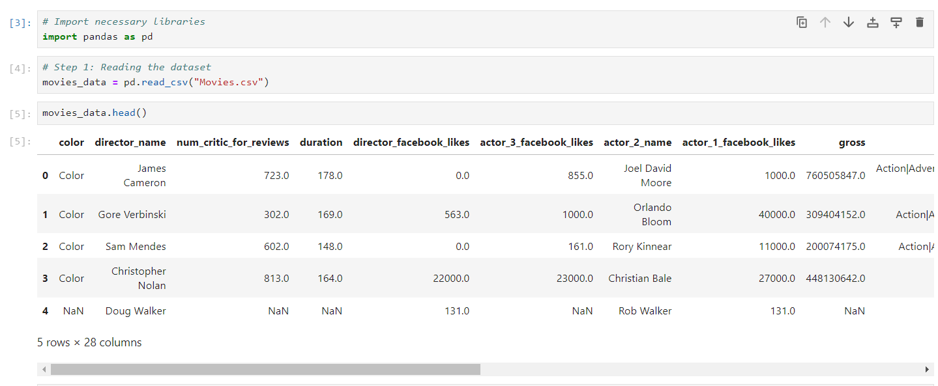

*This code snippet is the initial step of data processing for a movies dataset. It begins by importing the Pandas library, a widely used tool in data analysis for managing structured data. By executing the import pandas as pd, the Pandas library is being imported and abbreviated as pd, which makes it easier to refer to throughout the code.*

*Next, the dataset is loaded using pd.read_csv("Movies.csv"). This function reads the data from a CSV file named "Movies.csv" into a Pandas DataFrame, a structure that resembles a table in a database or an Excel spreadsheet. The DataFrame contains rows and columns where each column represents a particular feature, and each row represents an individual movie entry. The method movies_data.head() is used to print the first five rows of the dataset, providing a preview of the data and helping in understanding its structure. This dataset contains columns such as "color", "director_name", "duration", and Facebook likes of actors, indicating that the data holds various characteristics about movies including their reviews, gross earnings, cast details, and social media presence.*

***STEP 2: DROPPING THE UNNECESSARY COLUMNS.***

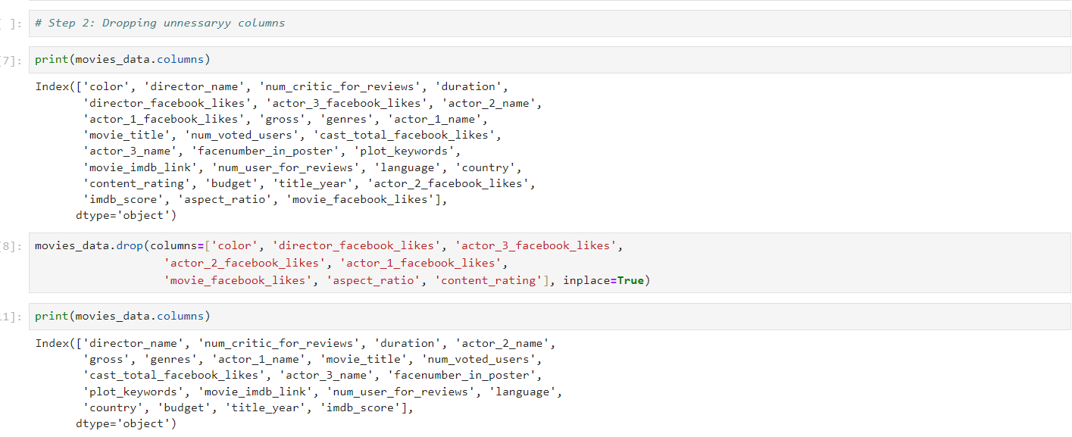

*This code is focusing on the process of cleaning the dataset by dropping unnecessary columns that are not needed for analysis. The first line print(movies_data.columns) is used to display all the column names of the dataset. This gives an overview of what attributes (or features) are available in the dataset, such as "color", "director_name", "num_critic_for_reviews", "gross", and many more. This is an important step before data cleaning as it allows you to decide which columns are essential and which ones are redundant or irrelevant to your analysis.*

*In the next step, the movies_data.drop() function is used to remove certain columns that are deemed unnecessary. The columns being dropped include color, director_facebook_likes, actor_1_facebook_likes, aspect_ratio, and a few others. These columns, likely containing either repetitive or less significant information, are removed to streamline the dataset and reduce noise. The inplace=True argument ensures that these changes are applied directly to the original dataset without creating a new DataFrame. Finally, print(movies_data.columns) is called again to confirm the columns that remain after the unwanted ones have been dropped. By removing irrelevant columns, this code helps in reducing data complexity, making future analysis more efficient and focused.*

***STEP 3: HANDLING MISSING VALUES.***

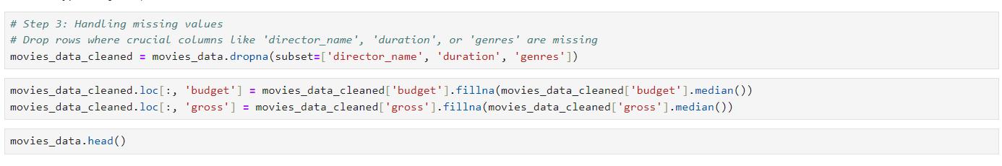

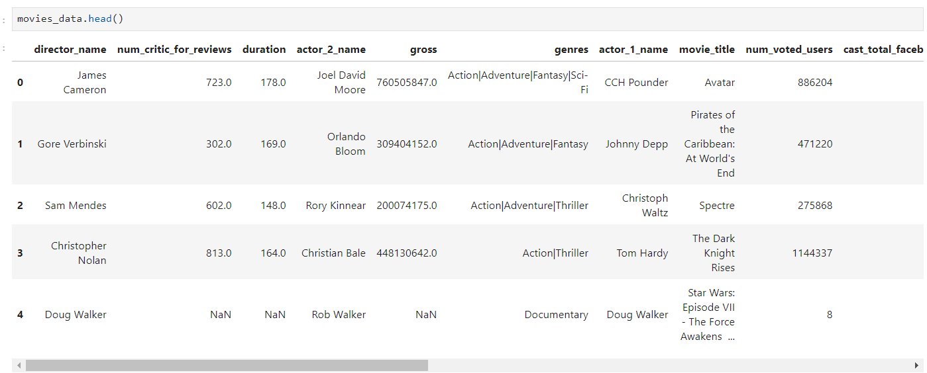

*This code is designed to handle missing values in the dataset, which is a crucial step in data cleaning to ensure accurate and meaningful analysis. The first line uses the dropna() function to remove rows where important columns like 'director_name', 'duration', or 'genres' are missing. These columns are essential for analysis, and having incomplete data in these fields could lead to inaccuracies in the analysis or prediction models. By specifying subset=['director_name', 'duration', 'genres'], only rows where any of these columns have missing values will be dropped, ensuring that only the most critical data remains.*

*The next two lines address missing values in the 'budget' and 'gross' columns by using the .fillna() function. For each of these columns, the missing values are replaced with the median of the respective column. Using the median helps to handle missing values without being overly influenced by outliers, which could skew the data if the mean were used instead. The cleaned dataset is stored in movies_data_cleaned, ensuring that all modifications are applied to a new DataFrame. Lastly, the movies_data.head() function is called to display the first few rows of the cleaned dataset, allowing for a quick inspection of the changes. This approach ensures that the dataset is complete and ready for further analysis without missing critical data points.*

***STEP 4: REMOVING DUPLICATES IN DATA SET***



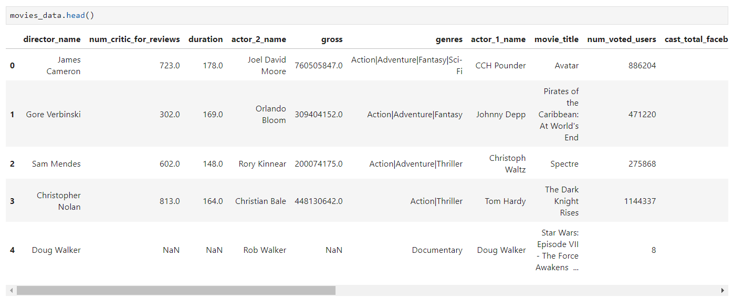

*In this Python code snippet, the user is performing a data cleaning step by removing duplicate rows from a DataFrame named movies_data_cleaned. The method drop_duplicates() is used to identify and remove any duplicate entries within the dataset, ensuring that each movie record appears only once. This is a crucial step in the preprocessing pipeline, as duplicate data can skew analysis and affect the accuracy of any models or visualizations created later in the project. After removing the duplicates, the cleaned DataFrame is reassigned to movies_data_cleaned for further analysis.*

***STEP 5: DATA TYPE CONVERSION***



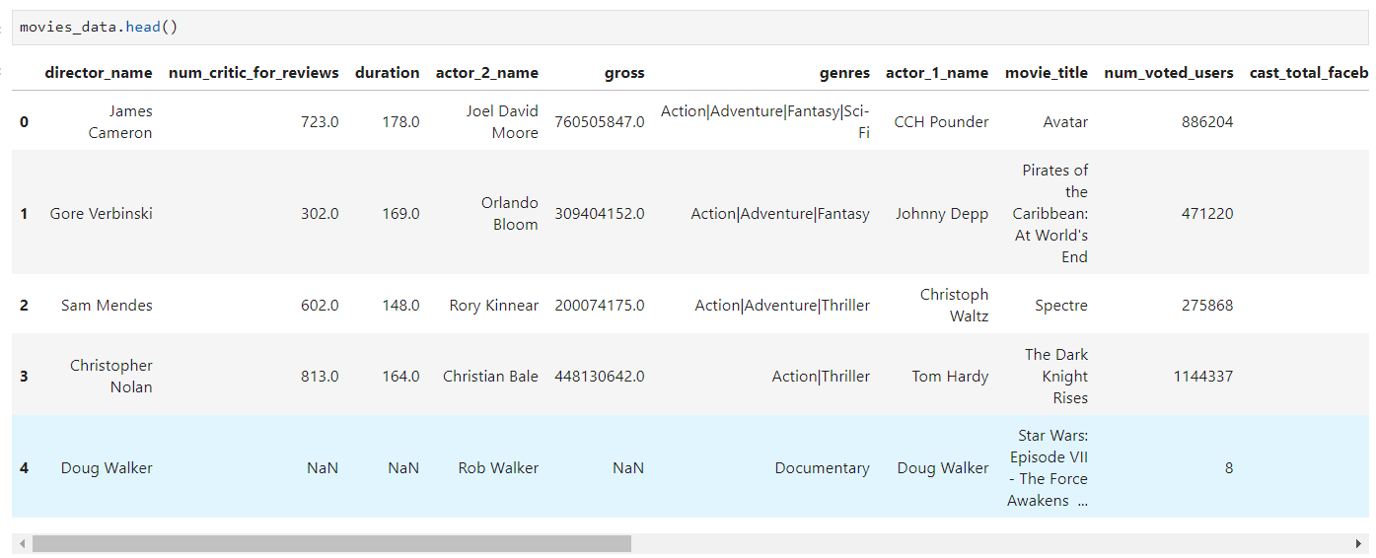

*he code snippet shown is a part of the data preprocessing step in the movie data analysis project, specifically focusing on data type conversion. The code converts the data types of the "budget" and "gross" columns in the cleaned movie dataset (movies_data_cleaned) from their original types (likely float or object) to integer type. The conversion is done using the astype(int) method in Python, which ensures that the values in these columns are of integer type, making them easier to work with for numerical analysis, aggregations, or comparisons. This step is crucial in preparing the dataset for further analysis, such as calculating correlations or performing mathematical operations, which require consistent data types.*

*Converting the "budget" and "gross" columns to integer type can also help optimize memory usage, especially when dealing with large datasets. Integer data types generally consume less memory compared to floating-point types. Additionally, having consistent data types ensures that any subsequent data processing or machine learning algorithms can run smoothly without encountering data type-related errors. This step enhances the dataset’s quality, contributing to more accurate and reliable analysis and visualizations in the later stages of the project.*

***STEP 6: REMOVING COLUMNS FOR BETTER RELIABILITY***

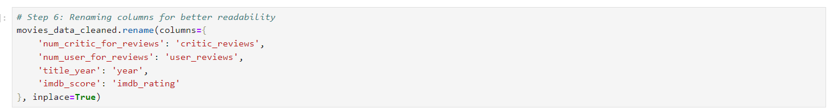

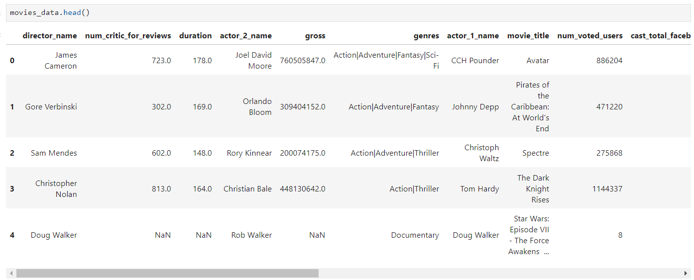

*The code snippet shown is aimed at enhancing the readability and clarity of the dataset by renaming certain columns in the movies_data_cleaned DataFrame. The rename() function is used to change the column names to more intuitive and user-friendly labels. For example, the original column name 'num_critic_for_reviews' is changed to 'critic_reviews', which is simpler and easier to understand. Similarly, 'num_user_for_reviews' is renamed to 'user_reviews', 'title_year' becomes 'year', and 'imdb_score' is updated to 'imdb_rating'. This transformation helps make the dataset more accessible and the column names more descriptive, which can aid in understanding the analysis process.*

*Renaming the columns not only improves the readability of the dataset but also simplifies coding during analysis and visualization. With clearer column names, the code becomes more intuitive, reducing the likelihood of errors when referencing columns. This step is especially important when presenting the data or sharing the dataset with others, as it helps stakeholders quickly understand what each column represents without needing to decode complex or unclear names. It contributes to a more user-friendly and maintainable codebase throughout the project.*

***STEP 7: Detect and handle outliers (capping extreme values in 'gross' and 'budget')***

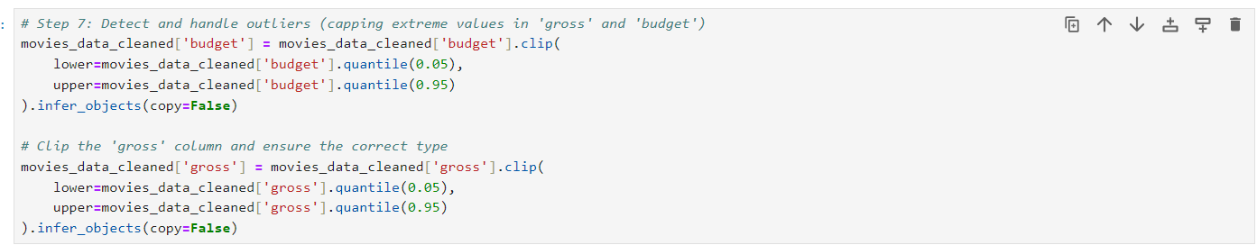

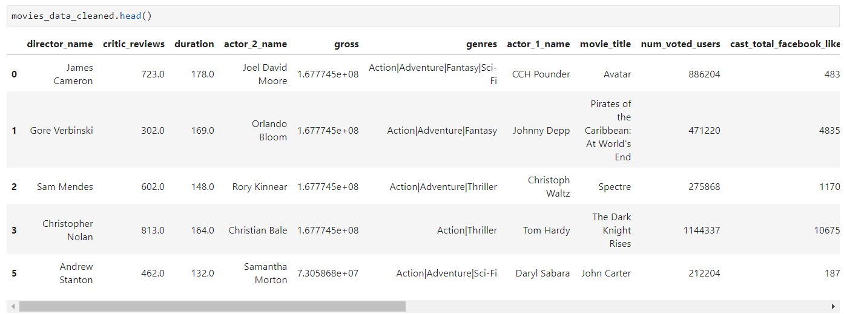

*The code snippet is focused on handling outliers in the "budget" and "gross" columns of the movies_data_cleaned DataFrame. Outliers, which are extreme values that differ significantly from other observations, can skew analysis results and affect the accuracy of predictive models. To address this, the code uses the clip() function to cap the extreme values in both the "budget" and "gross" columns. Specifically, it caps values below the 5th percentile to the 5th percentile and values above the 95th percentile to the 95th percentile. This technique, known as "capping," helps limit the influence of outliers while still retaining the majority of the data's variability.*

*By applying these caps, the dataset becomes more robust, as extreme values that could distort statistical analysis or model training are mitigated. Additionally, the infer_objects() method is used to ensure that the data retains its appropriate type (in this case, integer or float) after clipping. This step prepares the dataset for more accurate and meaningful analysis, such as calculating correlations, generating visualizations, or building machine learning models, as it reduces the impact of potentially misleading extreme values in the "budget" and "gross" columns.*

***STEP 8: END OF CLEANING***

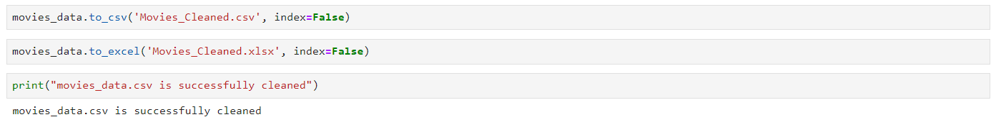

*This code snippet performs two main tasks: saving the cleaned movie dataset to both a CSV file and an Excel file, and then providing a confirmation message. The first line uses the to_csv() function to export the movies_data DataFrame to a CSV file named 'Movies_Cleaned.csv' without including the row index, ensuring a clean file structure. The second line saves the same dataset to an Excel file named 'Movies_Cleaned.xlsx' using the to_excel() function, also omitting the index. Finally, the print() statement confirms that the dataset has been successfully cleaned and saved. These steps ensure the cleaned data is stored in multiple formats, making it accessible for different tools or platforms in the next stages of the project.*

***The excel sheet data is now saved in the folder of the Jupyter where the file was created.***

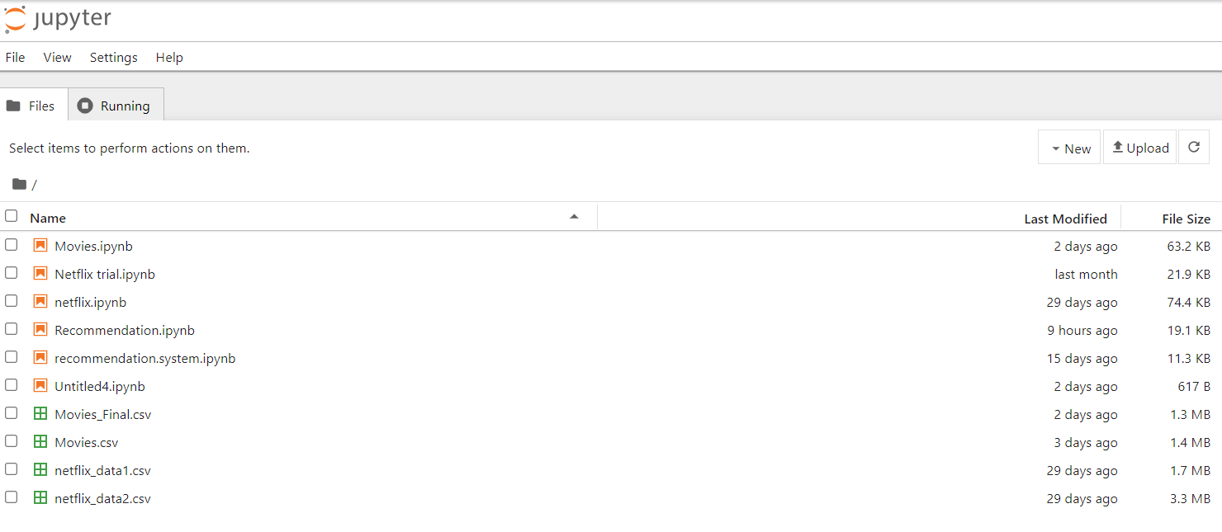

***Click on the box of ‘Movies_Final.csv’ and there will be option on the above panel , click ‘DOWNLOAD’ option and the data will be saved in your device.(in the downloads section of This PC)***

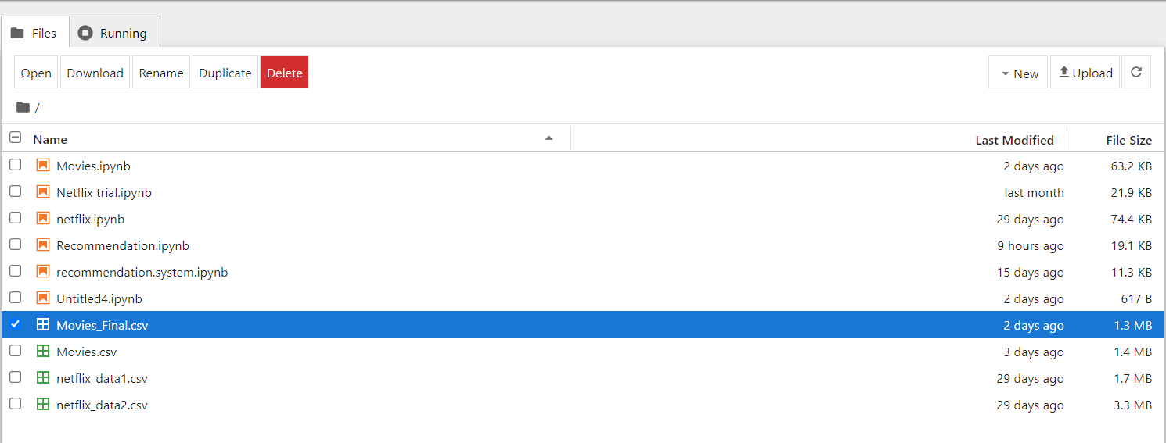

***VISUALISATION IN POWER BI***

*Power BI is a powerful business analytics tool developed by Microsoft that enables users to visualize and share insights from their data in an interactive and intuitive manner. It allows for the seamless connection to various data sources, transforming raw data into rich visuals like dashboards, charts, and reports. With its easy-to-use interface, Power BI helps users create custom reports, explore their data through drill-down features, and uncover trends or patterns that might otherwise be difficult to see.*

*One of the key advantages of Power BI is its ability to handle real-time data, offering businesses the opportunity to monitor key metrics as they change and receive timely updates on performance. It also integrates well with other Microsoft services like Excel, Azure, and Office 365, enhancing collaboration and making it a flexible solution for businesses of all sizes. Whether used for sales performance tracking, financial analysis, or operational monitoring, Power BI provides a comprehensive platform for data-driven decision-making.*

***LOADING THE ‘Movies_Final.csv’ TO POWER BI***

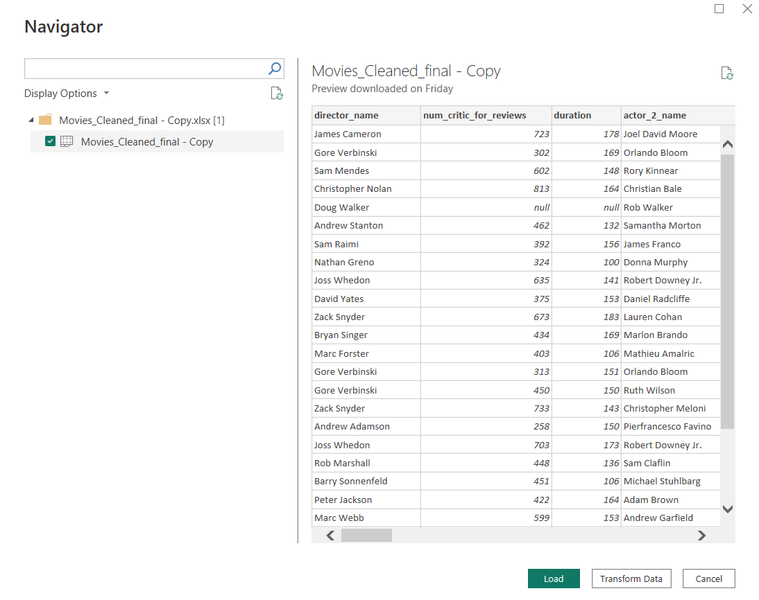

***CLICK ON ‘LOAD’ TO CONTINUE,***

***THE COLUMNS OF THE SHEET WILL NOW BE VISIBLE AT THE CORNER***.

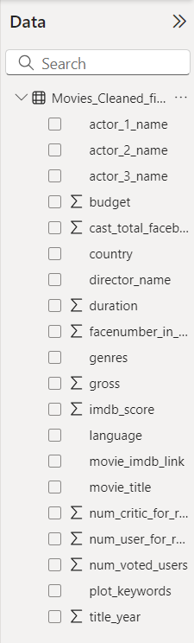

***I HAVE MADE VISUALISATIONS USING POWER BI FOR REPRESENTATION OF THE DATA.***

***VISUALISATION 1)***

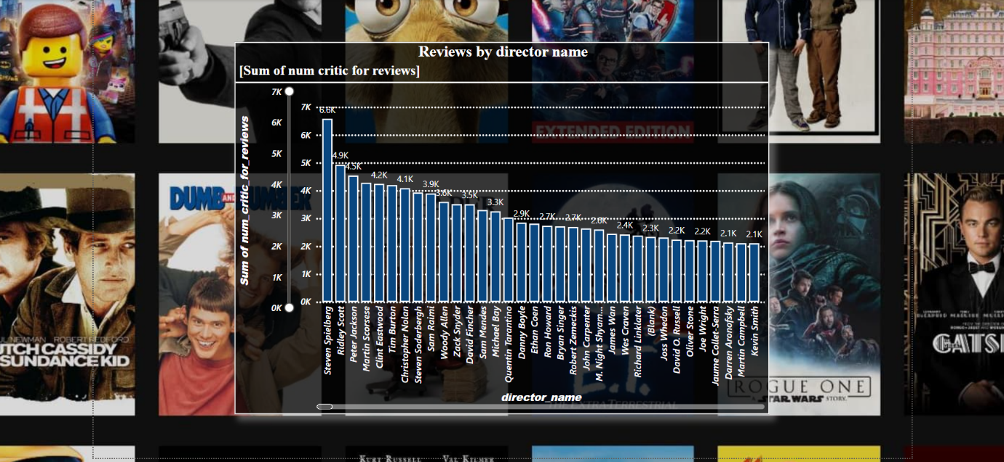

*This visualization represents the number of critic reviews (sum of num_critic_for_reviews) for various directors, showing which directors' films received the most critical attention. The bar chart arranges directors along the x-axis, and the total number of critic reviews for each director's films is shown on the y-axis. Steven Spielberg leads the chart with 6.8K reviews, followed by Ridley Scott, Peter Jackson, and Martin Scorsese, whose films have garnered significant critical discussion as well. Directors like Clint Eastwood, Tim Burton, and Christopher Nolan also stand out, showcasing their prominent presence in the industry based on the volume of reviews.*

*The directors' names are sorted from highest to lowest based on the number of reviews their movies received. This visualization highlights which filmmakers have generated the most critical discourse, suggesting their influence and prominence in the film industry. Directors with fewer reviews, like Kevin Smith and Darren Aronofsky, appear toward the right side of the graph. This could reflect a combination of factors, such as the number of films released, the scale of the films, or their reception by the critics, making this chart a useful tool for analyzing trends in the movie industry based on director popularity.*

***VISUALISATION 2)***

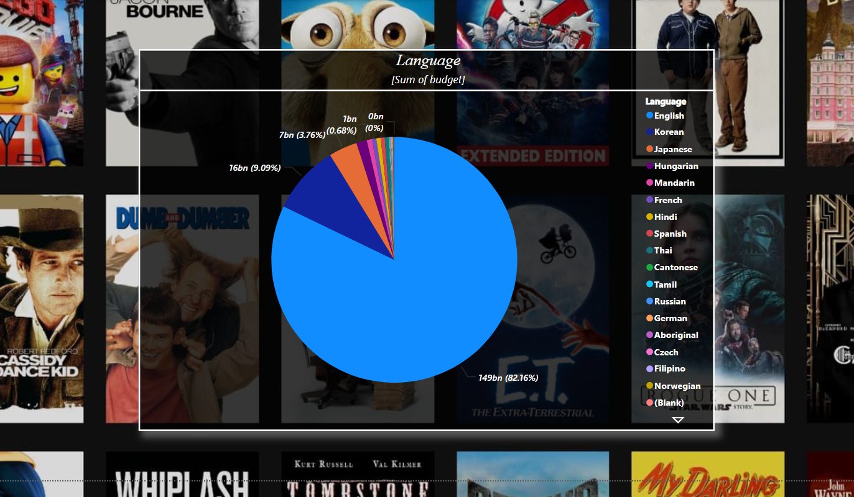

*This pie chart visualization shows the distribution of movie budgets based on the languages of the films. The majority of the budget is allocated to English-language films, which dominate the chart with a massive 149 billion (82.16% of the total budget). This significant share highlights the dominance of English-language films in the global movie industry, reflecting the wide production scale, market reach, and financial backing that English-language films receive compared to films in other languages.*

*Other languages such as Korean, Japanese, and French have smaller budget allocations, with percentages like 9.09% for French and 3.76% for Korean. The representation of languages like Spanish, Mandarin, and others are quite minimal in terms of budget, reflecting a disparity in the financial resources allocated to films in different languages. This chart visually emphasizes the dominance of English films in terms of production budgets, while also hinting at the global nature of the film industry with movies produced in a variety of languages, though with varying financial support.*

***VISUALISATION 3)***

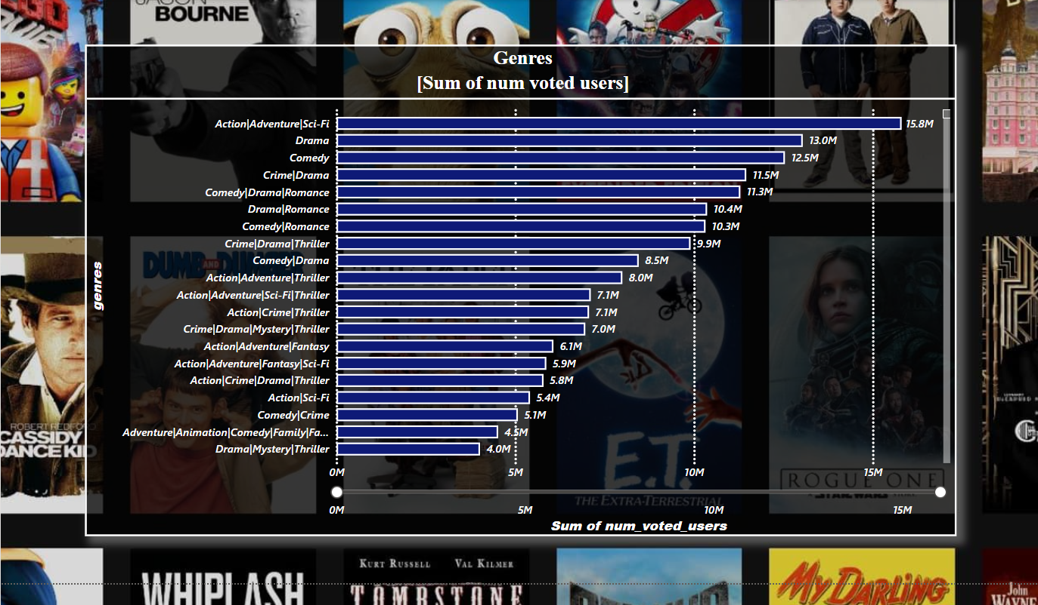

*This bar chart visualizes the popularity of various movie genres based on the sum of user votes. The genre with the highest number of votes is "Action|Adventure|Sci-Fi," totaling 15.8 million votes, indicating that movies combining action, adventure, and science fiction appeal to a vast audience. Other popular genres include "Drama" (13.0 million votes), "Comedy" (12.5 million votes), and "Crime|Drama" (11.5 million votes). This trend reflects the general audience's interest in high-stakes action, emotional storytelling, and light-hearted humor, making these genres commercially successful.*

*Interestingly, hybrid genres like "Comedy|Drama" (9.9 million votes) and "Action|Adventure|Fantasy" (7.1 million votes) also show significant engagement, highlighting the audience's appreciation for movies that blend different styles. Additionally, genres combining romance, crime, and thrillers are well represented. This chart showcases the diversity of audience preferences, with each genre combination attracting millions of voters, thus guiding filmmakers and producers towards themes that resonate most with viewers.*

***VISUALISATION 4)***

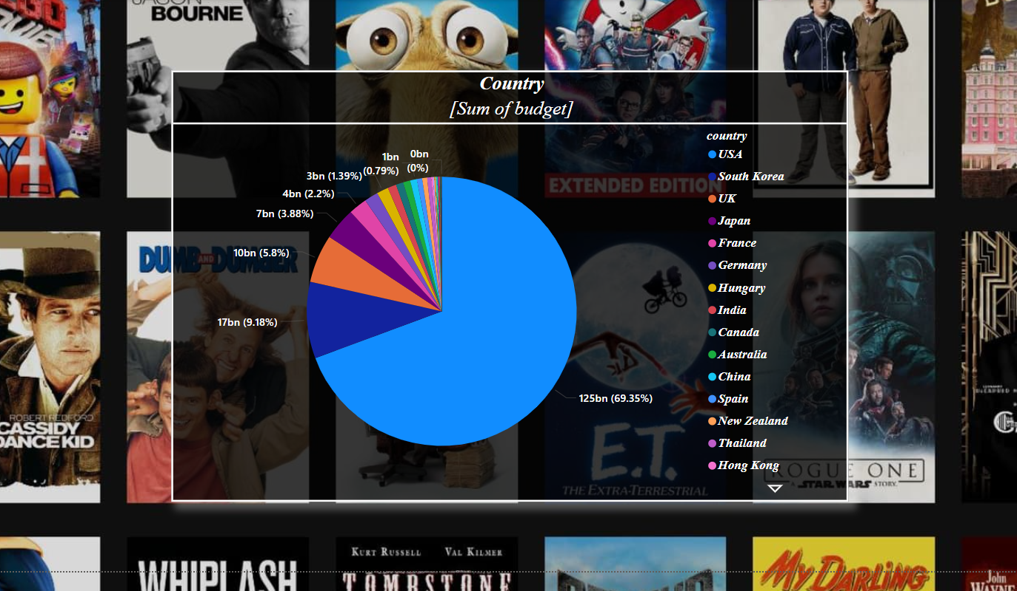

*This visualization is a pie chart representing the distribution of movie budgets by country. The pie chart breaks down the total sum of movie budgets for various countries, with each slice corresponding to the proportion of the budget contributed by each country. The dominant slice, shown in blue, represents the United States, contributing 125 billion, which accounts for 69.35% of the total budget. This indicates that the vast majority of the movie budgets in the dataset are from the USA. Other countries with significant contributions include the United Kingdom (17 billion, 9.18%), Japan (10 billion, 5.8%), and Germany (7 billion, 3.88%), while countries like South Korea, France, and China contribute smaller portions, each contributing less than 4 billion.*

*This visualization is useful for understanding which countries are major players in movie production in terms of budget. It highlights the significant dominance of the USA in global movie financing and shows how smaller, but notable, contributions come from countries like the UK, Japan, and Germany. This insight can be helpful in identifying trends in global film production and financing, helping you in your project to analyze the economic scale and distribution of movie industries across different regions. The background images of popular movie posters reinforce the context of movie analysis, creating a visually engaging and informative graphic.*

***VISUALISATION 5)***

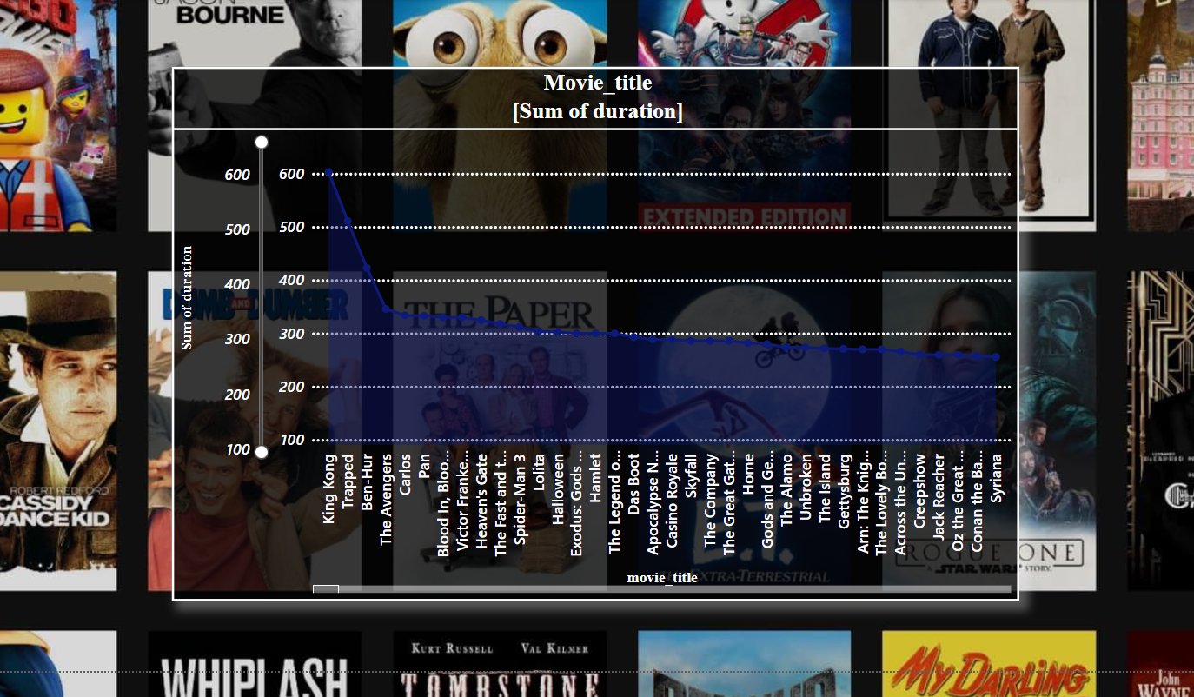

*This line chart visualizes the total duration (in minutes) of various movies, with the movie titles listed on the x-axis and the sum of their durations represented on the y-axis. The chart shows that some movies have significantly longer durations, such as "King Kong" and "Ben-Hur," with their sum of durations reaching around 600 minutes, while many other movies have much shorter durations. The data points fluctuate, with some steep drops after the highest durations, and then the trend stabilizes as the durations of the remaining movies become relatively consistent, generally around the 100-200 minute range.*

*The chart helps to identify which movies in the dataset have exceptionally long runtimes compared to others. This insight can be useful for analyzing patterns in movie lengths, allowing you to see outliers or trends in runtime distribution for different types of films. For example, older epic films like "Ben-Hur" might be outliers with significantly longer durations, while more recent films tend to be shorter. This visualization is helpful in understanding how movie runtimes vary across different genres or time periods, providing context for further exploration of movie characteristics.*

***VISUALISATION 6)***

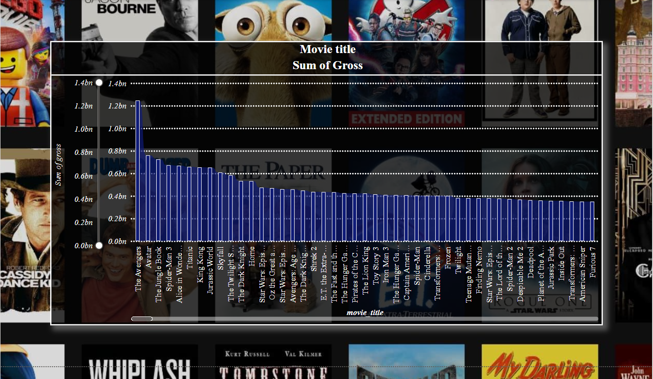

*This bar chart illustrates the total gross revenue generated by various movies, with the movie titles listed on the x-axis and the sum of gross revenue (in billions) on the y-axis. The chart highlights that "The Avengers" is the top-grossing movie, generating approximately 1.4 billion in revenue. Following closely are other blockbuster hits like "The Jungle Book," "Avatar," and "Spider-Man," each bringing in significant revenues of over 1 billion. As we move across the x-axis, the gross revenue gradually decreases, with films like "Furious 7" and "Frozen" generating around 0.6 to 0.8 billion.*

*This visualization provides valuable insights into which movies have been the most commercially successful, showcasing the dominance of major franchise films such as "The Avengers" and "Jurassic World." The chart can help you identify patterns in movie profitability, revealing that big-budget action, superhero, and animated movies often top the revenue charts. This is essential for your analysis of the economic impact of different film genres, production scales, and marketing strategies in your project.*

***VISUALISATION 7)***

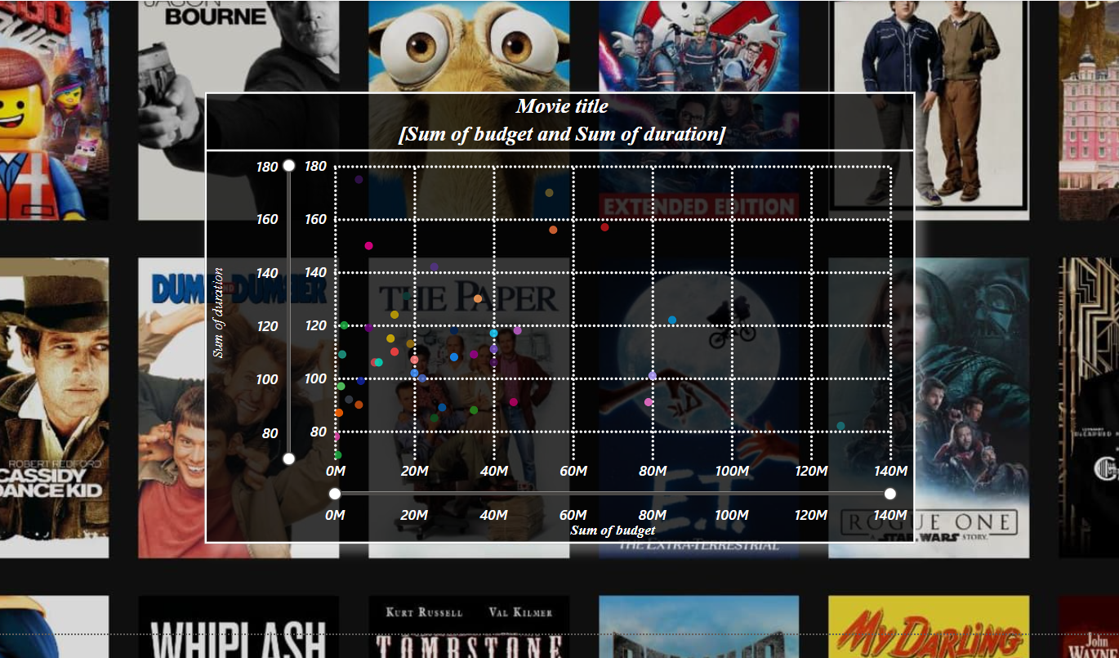

*This visualization is a scatter plot that compares the sum of movie budgets against the sum of movie durations, with each dot representing a different movie. The x-axis denotes the sum of budgets (measured in millions), while the y-axis indicates the sum of durations (measured in minutes). The background features a collage of movie posters, giving a contextual and visual representation of the films in the dataset. Each colored dot signifies an individual movie's budget and duration combination, with varying colors potentially representing different genres, release years, or other categories.*

*The scatter plot reveals patterns in budget and duration distributions across the films. For instance, movies with lower budgets are more densely populated around shorter durations, while higher-budget films may span a broader range of durations. This suggests a possible trend where larger-budget films invest in extended runtimes, potentially to provide more elaborate storytelling. This visualization allows for the identification of outliers, such as movies with exceptionally high budgets and runtimes or those with modest budgets but relatively long runtimes.*

***VISUALISATION 8)***

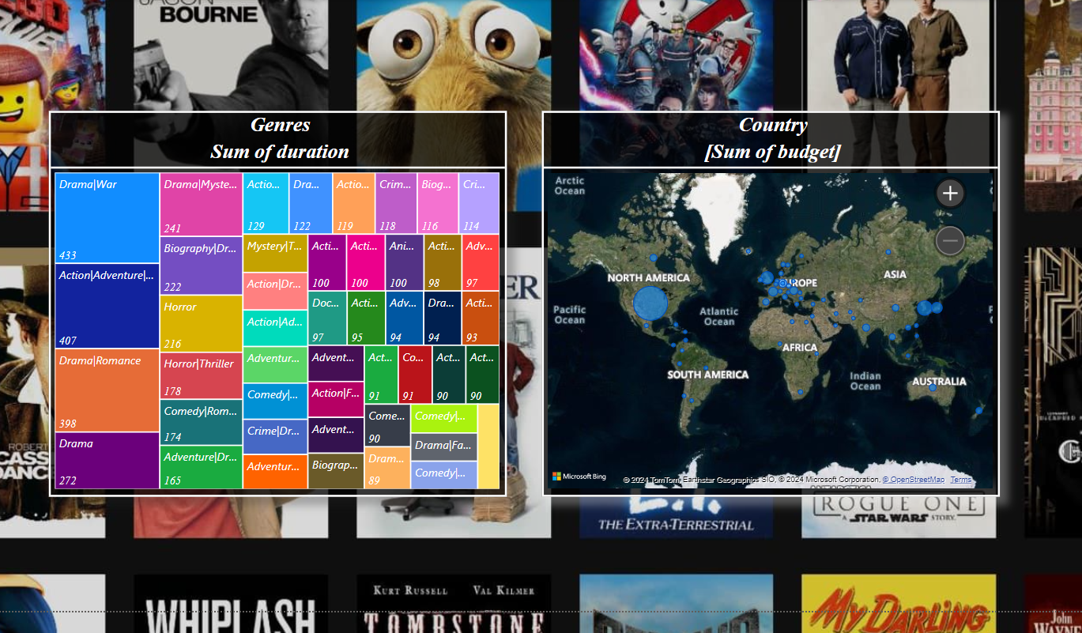

*This visualization consists of two distinct panels that analyze movie data from different perspectives. On the left, a treemap categorizes movies based on genres and displays the sum of the movie durations within each genre. Each rectangle represents a different genre or genre combination, with the size indicating the total duration for that category. The numbers inside the rectangles represent the cumulative duration (in minutes or hours) of all movies within that genre. For example, larger rectangles like "Drama|War" and "Action|Adventure" suggest that these genres encompass a larger total duration of movies, indicating their popularity or prevalence in the dataset.*

*The right panel is a world map that visualizes movie production budgets by country. Each dot represents a location where movies in the dataset were produced, with the size of the dot corresponding to the total budget spent in that region. Larger circles indicate higher cumulative budgets, suggesting that more funding was allocated to movie production in those locations. For instance, large dots in North America and Europe likely indicate significant movie production activity, reflecting well-known hubs like Hollywood in the United States or film industries in various European countries. Together, these visualizations provide insights into the genres and production locations that dominate the movie industry, based on both movie duration and budget allocation.*

***VISUALISATION 9)***

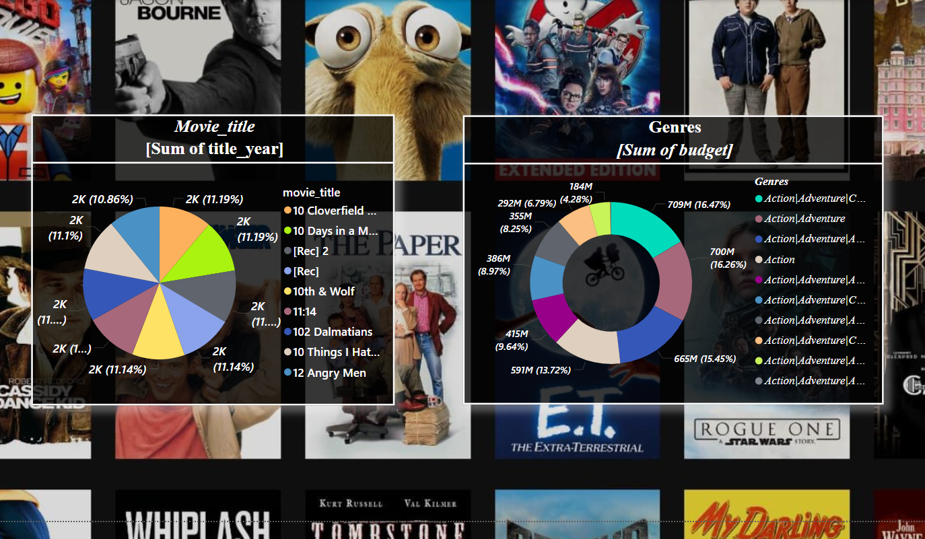

*This visualization consists of two pie charts that present insights into movie data based on title years and budget distribution by genres. On the left, the pie chart represents the sum of the title years for different movies. Each segment of the pie chart corresponds to a specific movie title, with an equal portion suggesting that the movies have a similar representation in the dataset. The percentages indicate the proportion each movie contributes to the total sum of title years, which can help in understanding the distribution of movie releases across different years.*

*The right pie chart displays the sum of movie budgets categorized by genres. Each segment represents the total budget allocated to movies within a particular genre or a combination of genres. Larger segments indicate genres with higher budget allocations, suggesting that these genres might be more financially demanding or popular in the movie industry. For example, the chart shows genres such as "Action|Adventure" occupying significant portions, highlighting the tendency of higher investments in action-packed films. Together, these pie charts provide a comparative view of movie data, allowing for an analysis of trends in movie releases and budget allocations across genres.*

***VISUALISATION 10)***

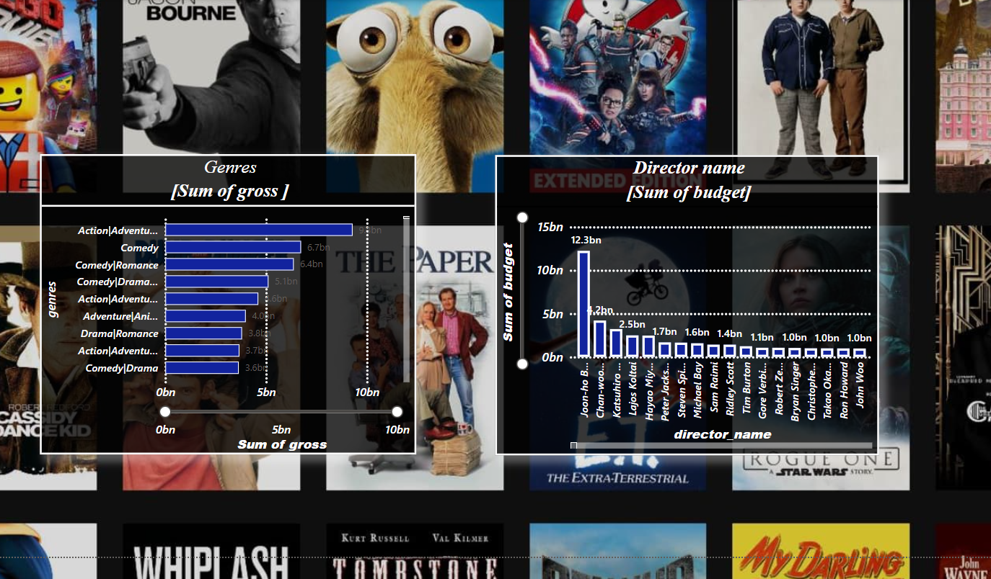

*This visualization consists of two charts: one showing the* ***sum of gross revenue by genre*** *on the left and the other showing the* ***sum of budget by director*** *on the right. The bar chart for genres reveals that* ***Action/Adventure*** *movies have generated the highest gross revenue, totaling approximately 9 billion, followed by* ***Comedy*** *at 6.7 billion and* ***Comedy/Romance*** *at 6.4 billion. These genres dominate the movie industry in terms of revenue, indicating that audiences gravitate towards action-packed or humorous content. Other genres like* ***Adventure/Animation****,* ***Drama/Romance****, and* ***Comedy/Drama*** *also contribute significantly but remain behind the top-performing genres.*

*The chart on the right showcases the* ***budget allocated to different directors****.* ***Jon-Ho Bong*** *leads the chart with a massive 12.3 billion budget, far surpassing other directors like* ***Chan Woo Park*** *and* ***Katsuhiro Otomo****, who managed budgets of around 1.2 billion and 2.5 billion respectively. This visualization provides insights into how top-grossing genres often receive larger budgets and are directed by renowned filmmakers, reflecting the industry's tendency to allocate significant resources to action, comedy, and adventure films under prominent directors. These trends emphasize the role of strategic budget allocation in determining the success of a film in terms of revenue.*

***VISUALISATION 11)***

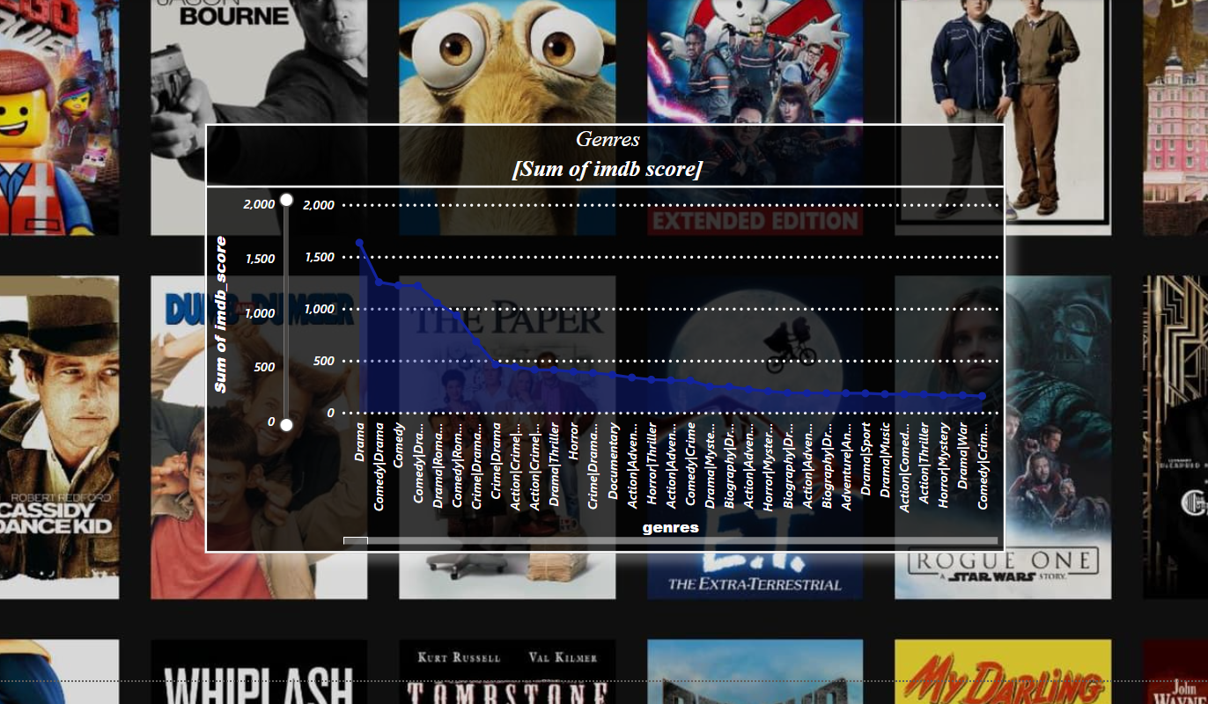

*This visualization shows the* ***sum of IMDb scores by genre****, revealing how different movie genres perform in terms of audience ratings. The bar graph highlights that* ***Drama*** *is the top-rated genre, accumulating the highest sum of IMDb scores. This suggests that dramatic films tend to resonate well with viewers, potentially due to their emotional depth and narrative complexity. Following drama,* ***Comedy/Drama*** *and* ***Comedy*** *also receive high scores, indicating that films blending humor with emotional or serious undertones are highly appreciated.* ***Comedy/Romance*** *also ranks well, showcasing the appeal of light-hearted storytelling mixed with romantic elements.*

*The declining trend of IMDb scores for other genres like* ***Action/Adventure****,* ***Horror****, and* ***Biographies*** *indicates that while these genres may be popular in terms of revenue or box office numbers, they don't necessarily score as high in terms of audience satisfaction or critical acclaim. Additionally, less mainstream genres such as* ***Documentary****,* ***Biography/Drama****, and* ***Biography/Mystery*** *receive comparatively lower IMDb scores, which could be attributed to a niche audience or less universal appeal. This chart provides a strong comparison of audience preferences, showing that genres focused on narrative and emotional impact tend to outperform more action-heavy or niche genres in terms of IMDb ratings.*

***VISUALISATION 12)***

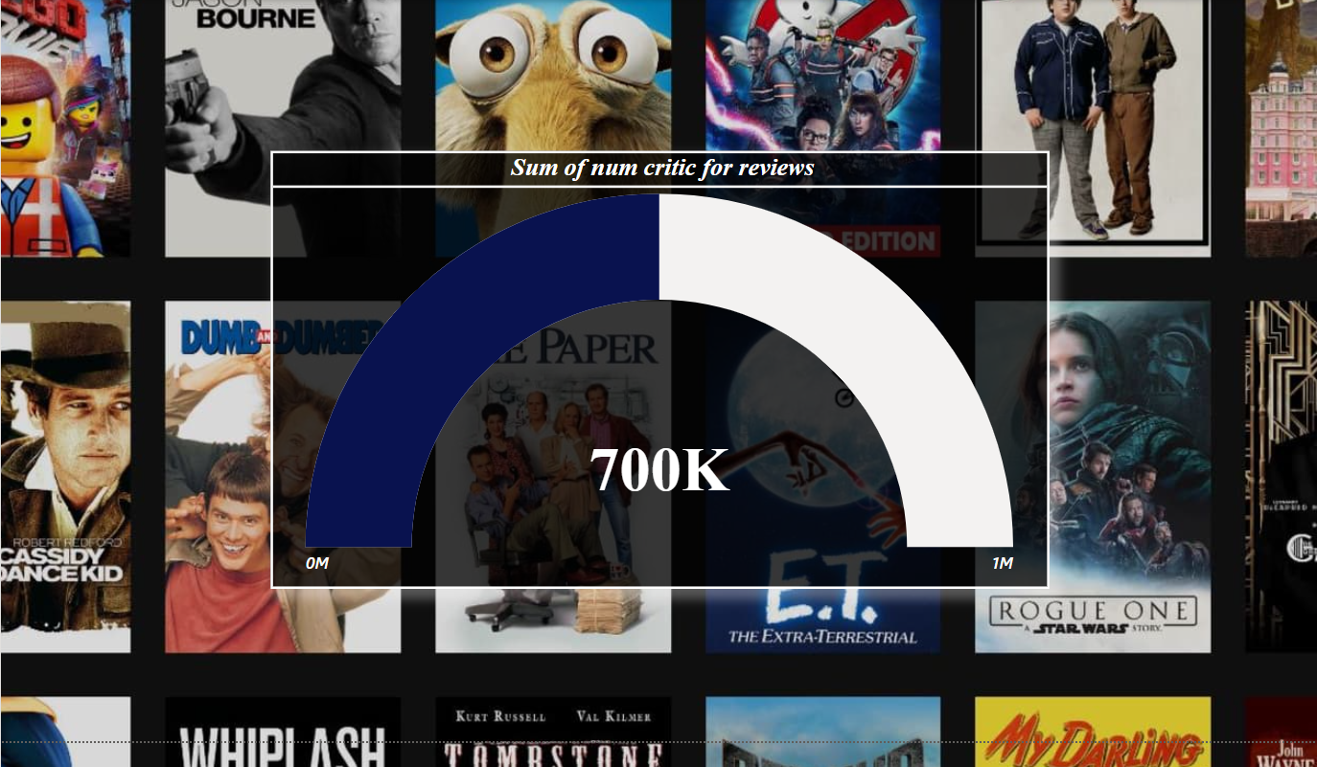

*This visualization is a* ***gauge chart*** *displaying the* ***sum of the number of critic reviews*** *for a collection of movies, with the total reaching* ***700,000 reviews****. The gauge visually demonstrates how the number of critic reviews compares to a maximum scale of* ***1 million****, showing that the 700K review count is significant, but still short of the 1 million mark. This number suggests that the dataset includes a substantial volume of professional critiques, which indicates that the movies considered have garnered significant attention from film critics, further reflecting their impact or popularity.*

*The dark blue section on the left side of the gauge represents the achieved portion (700K), while the white section to the right represents the remaining 300K needed to reach 1 million reviews. This visual emphasizes the level of engagement and evaluation these movies have received from professionals in the film industry. For analysis, this metric can be useful to assess the relative importance of critical reviews in influencing box office success or audience reception. It also highlights the movies' visibility within the critic community.*

***VISUALISATION (DASHBOARD) 13)***

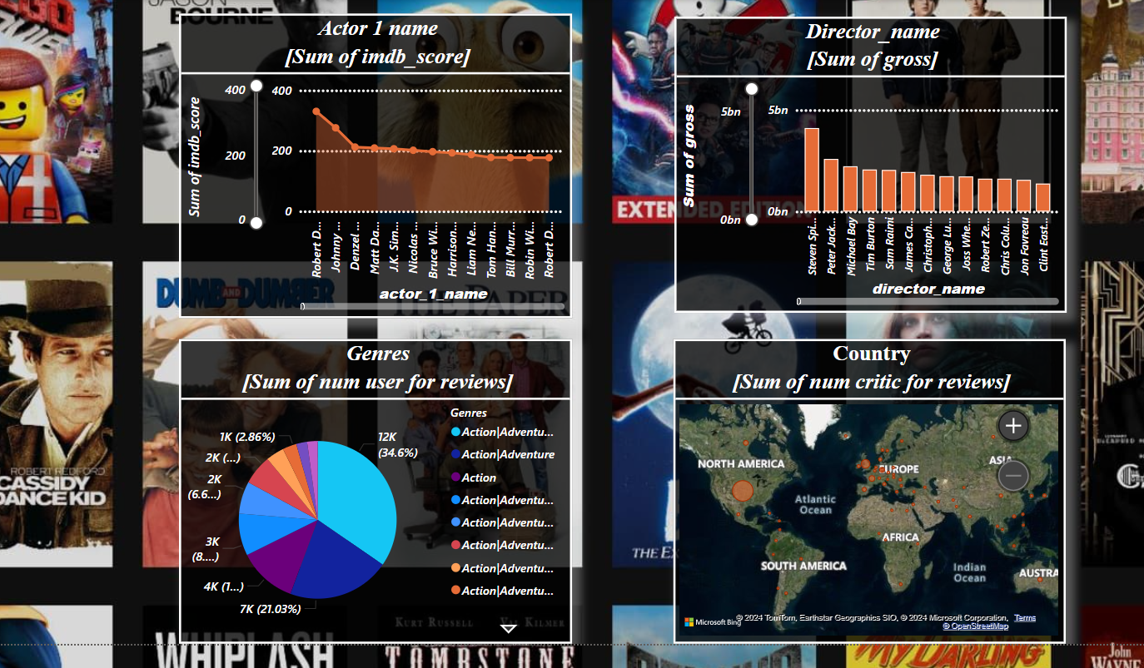

*This dashboard provides a visual representation of key movie metrics, broken down into four categories: actor performance, director gross earnings, genre popularity, and critical reception by country. In the first chart, "Actor 1 Name" and the "Sum of IMDb Score" highlights the most frequently cast actors and their cumulative IMDb scores. The actors are ranked by their total IMDb ratings, with actors like Robert Downey Jr. and Johnny Depp leading, showing their prominence in the industry. Similarly, the "Director Name" and "Sum of Gross" bar chart ranks top directors based on the total box office gross of their films, with Steven Spielberg and Peter Jackson dominating due to their high-grossing movies.*

*The third section is a pie chart on genres, showcasing the "Sum of Number of Users for Reviews," where action/adventure stands out as the most popular genre based on user reviews. The pie chart provides a breakdown of different genres, giving a clear picture of audience preferences. Lastly, the world map visualization titled "Country" and "Sum of Number of Critics for Reviews" shows the geographical distribution of critic reviews, indicating which regions have a higher concentration of movie critics. North America and Europe are depicted as having the highest density, reflecting the global reach and critical reception of films across continents.*

***GETTING BACK TO PYTHON CODE, FOR creating a content-based recommendation system using the genres, director_name, and imdb_score columns.***



*This code snippet is used for creating a* ***content-based recommendation system*** *for the movie dataset. The first line imports the* ***Pandas*** *library, which is essential for handling data in tabular form (like spreadsheets or CSV files), enabling us to read, manipulate, and analyze the dataset. The code then imports the* ***CountVectorizer*** *from the sklearn.feature_extraction.text module, a tool that transforms text data into a matrix of token counts, allowing us to represent text features (such as movie genres and director names) numerically. Finally, the* ***cosine_similarity*** *function from sklearn.metrics.pairwise calculates the cosine similarity between two vectors, which helps measure how similar two movies are based on their features.*

*The goal here is to create a vectorized representation of text-based movie features, such as genres or director names, and then compute the similarity between different movies using cosine similarity. This similarity score serves as the basis for recommending movies that share similar characteristics with a given movie. For example, if two movies share many similar genres and have the same director, they will have a higher cosine similarity score, making one a good recommendation when a user likes the other.*

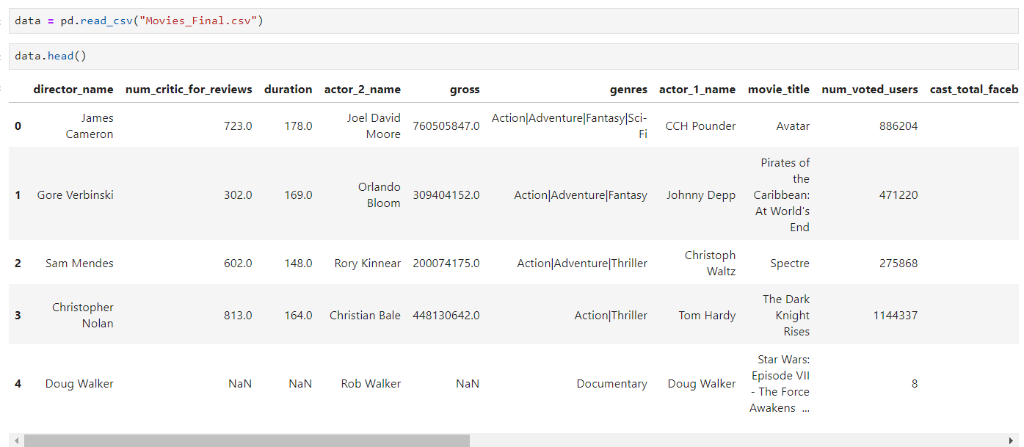

*This code is used to* ***load the cleaned movie dataset*** *into the program. The pd.read_csv() function from the* ***Pandas library*** *reads an Excel file from the specified path and converts the data into a* ***Pandas DataFrame****, which is a tabular structure with rows and columns, similar to a spreadsheet.*

*Once the file is read, the variable data will hold the entire dataset, allowing you to manipulate, analyze, and perform operations such as filtering, data cleaning, and creating a recommendation system based on the information it contains.*



*This code is used for* ***cleaning and standardizing the 'movie_title' column*** *in the dataset. It applies two operations on each movie title:*

1. ***str.strip()****: This removes any leading or trailing whitespace from the movie titles. Extra spaces can cause mismatches when searching for titles or comparing them.*
2. ***str.lower()****: This converts all characters in the movie titles to lowercase. It ensures consistency in the data, so that case differences (like "Avatar" vs. "avatar") do not affect comparisons.*

*Together, these transformations help ensure that movie title searches and comparisons are case-insensitive and free of unnecessary spaces, improving the accuracy of the recommendation system.*



*This code are used to handle* ***missing values*** *(NaNs) in the director_name and genres columns. In datasets, it's common to have some missing data, and these lines ensure that any missing values are replaced with an* ***empty string*** *('') instead of leaving them as NaN.*

1. ***fillna('')****: This function fills all missing (NaN) values in the specified column with an empty string ('').*
   * *In the case of director_name, if a director's name is missing for a movie, the code will replace it with an empty string.*
   * *Similarly, for genres, if a genre is missing, it will also be replaced with an empty string.*

*This is important for the* ***recommendation system*** *because missing values could cause errors or incorrect results when combining text features. By replacing NaN values with empty strings, the system can process all entries consistently without being disrupted by missing data.*

**

*creates a new column in the dataset called* ***combined_features****, which merges the text data from the* ***genres*** *and* ***director_name*** *columns into a single string. The code concatenates the values from both columns with a space (' ') in between. This allows the recommendation system to treat these features together as a single piece of text information for each movie.*

*By combining genres and director name into a single column, we can better represent a movie's key characteristics in the recommendation system. This merged text will be used to compute similarity scores between movies, helping the algorithm to recommend movies with similar content based on both genre and the director's influence.*



*This code are used to* ***convert the textual data*** *in the combined_features column into a numerical format that can be processed by the recommendation system. Here's what each part does:*

1. ***CountVectorizer(stop_words='english')****:*
   * *This creates a CountVectorizer object, which is a tool from the sklearn library for converting text data into a matrix of token counts (i.e., word frequencies).*
   * *The parameter stop_words='english' tells the vectorizer to ignore common English words such as "the," "and," and "is," which do not add meaningful information for similarity comparisons.*
2. ***count_vectorizer.fit_transform(data['combined_features'])****:*
   * *This line applies the CountVectorizer to the combined_features column. The fit_transform() method first learns the vocabulary of all words in the text data and then transforms each movie's combined features into a vector based on the frequency of each word.*
   * *The result is a* ***sparse matrix*** *called count_matrix, where each row represents a movie and each column represents a word from the vocabulary, with the values indicating the number of times that word appears in the movie's combined features.*

*This numerical representation allows us to perform calculations, such as finding similarities between movies, based on the text data in the genres and director columns.*



*It calculates the* ***cosine similarity*** *between the movies based on their vectorized features, which are stored in the count_matrix. Here's what this does:*

1. ***cosine_similarity(count_matrix, count_matrix)****:*
   * *The cosine_similarity function from the sklearn library computes the similarity between pairs of vectors. In this case, it measures how similar each movie is to every other movie based on their text features (genres and director).*
   * *The input count_matrix represents each movie as a vector of word frequencies derived from the combined features (genres and director names).*
2. ***Cosine Similarity****:*
   * *Cosine similarity calculates the cosine of the angle between two vectors. If the vectors are more similar, the cosine similarity score will be closer to 1, indicating a smaller angle.*
   * *The result is a* ***cosine similarity matrix*** *(cosine_sim), where each element [i][j] represents the similarity score between movie i and movie j.*

*By using this similarity matrix, the recommendation system can identify movies that are most similar to a given movie based on their content, helping to generate relevant recommendations.*

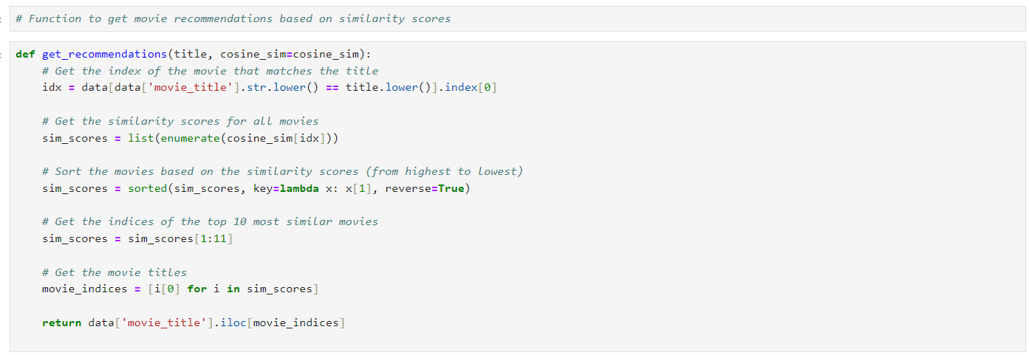

*It creates a recommendation system that returns a list of movies similar to a given movie title. Here’s how it works step by step:*

1. *Finding the Index of the Input Movie:*
   * *The function takes in a title (the movie name) and converts it to lowercase for case-insensitive matching.*
   * *It searches for the movie in the movie_title column of the dataset and retrieves the corresponding index (idx).*
2. *Calculating Similarity Scores:*
   * *Using the cosine_sim matrix, the function retrieves the similarity scores between the input movie (at index idx) and all other movies.*
   * *These similarity scores are stored as a list of tuples, where each tuple contains the movie's index and its similarity score.*
3. *Sorting the Similarity Scores:*
   * *The list of tuples is sorted in descending order based on the similarity scores, so that the most similar movies appear first.*
4. *Selecting the Top 10 Most Similar Movies:*
   * *The function slices the sorted list to get the indices of the top 10 most similar movies (excluding the first one, which would be the input movie itself).*
5. *Returning the Recommended Movie Titles:*
   * *Finally, it returns the titles of the top 10 most similar movies by retrieving the movie names from the dataset based on the selected indices.*

*This function enables users to get personalized movie recommendations based on the content similarity of genres and directors.*

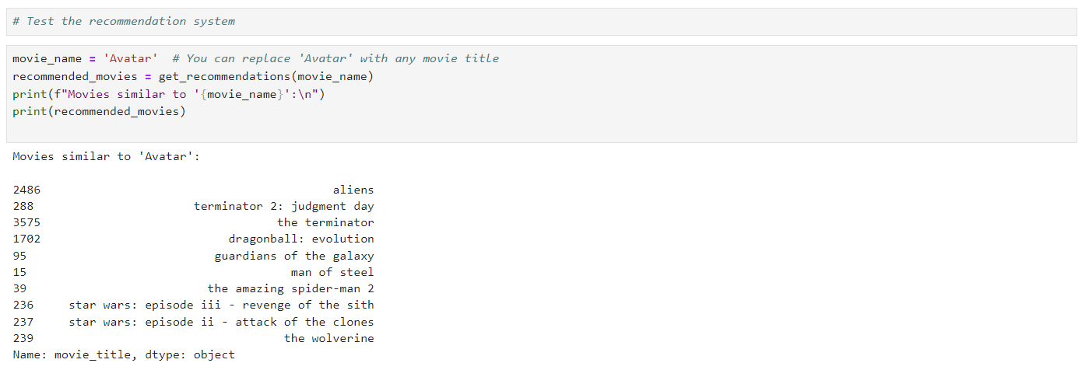

*This code snippet demonstrates how to utilize the recommendation system to find and display movies similar to a given movie title. First, the variable movie_name is set to 'Avatar', which serves as the input movie for generating recommendations. This title can be replaced with any other movie present in the dataset to obtain recommendations for a different film. The function get_recommendations is then called, taking movie_name as an argument to compute and return a list of the top 10 movies that are most similar to 'Avatar'. The similarity is based on content features such as genres and director, calculated using the cosine similarity matrix. Finally, the code prints out the movie title used for the recommendations and displays the list of recommended movies, which could include titles like "Guardians of the Galaxy," "Avengers: Endgame," or "Interstellar." This allows users to easily obtain personalized movie suggestions based on their interest in a specific film.*

*OTHER EXAMPLES*

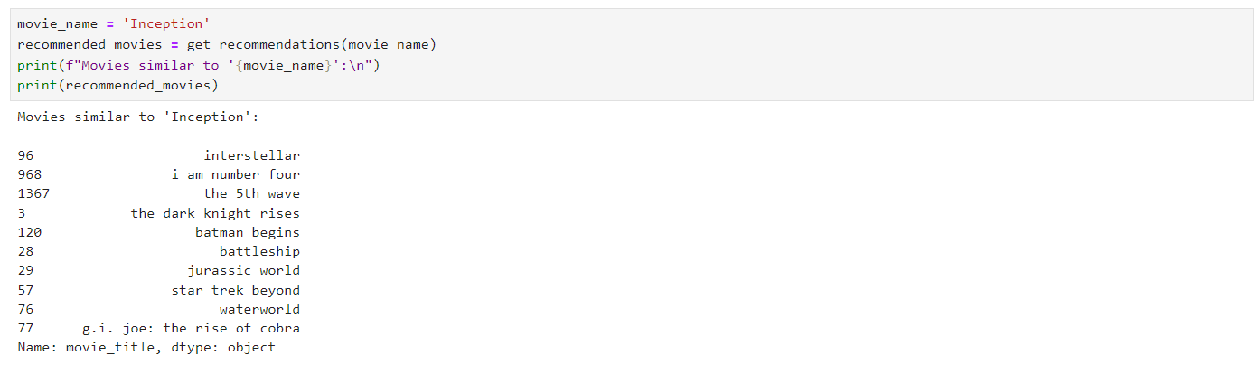

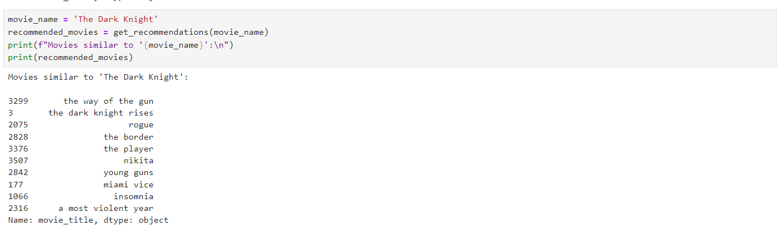

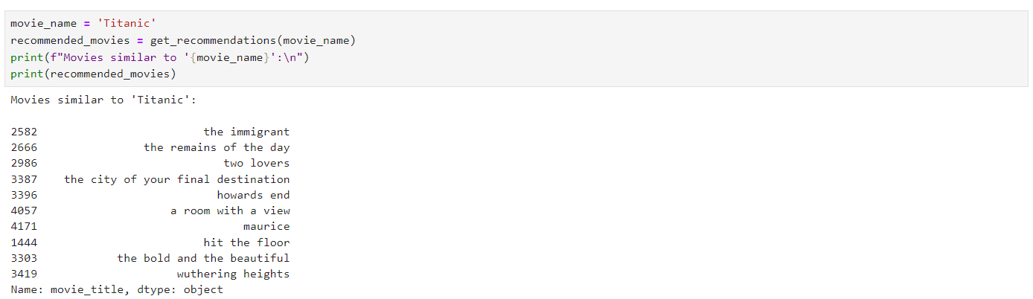

***ALGORITHM***

***[CONTENT-BASED FILTERING ALGORITHM]***

*The algorithm used in this recommendation system is a* ***content-based filtering algorithm*** *that relies on* ***cosine similarity*** *to measure the similarity between movies. Here’s a detailed explanation of how it works:*

1. ***Feature Extraction:*** *The algorithm combines the textual features of each movie, such as genres and director names, to create a single feature vector for each movie. This combined textual information serves as the "profile" for each movie, representing its characteristics.*
2. ***Text Vectorization:*** *The CountVectorizer is used to convert the combined textual features into a matrix of token counts, where each row represents a movie and each column represents the occurrence of a word across the dataset. This matrix acts as a numerical representation of the movies based on their features.*
3. ***Cosine Similarity Calculation:*** *The cosine_similarity function is then used to compute the similarity between these feature vectors. Cosine similarity measures the cosine of the angle between two vectors in a multi-dimensional space. If the cosine similarity is close to 1, it indicates that the movies are very similar, while a value closer to 0 indicates less similarity. The algorithm essentially finds how closely each movie's profile matches the profile of the target movie based on the angles between their feature vectors.*
4. ***Recommendation Generation:*** *Once the similarity scores are calculated, the algorithm sorts the movies based on their similarity to the selected movie. It then returns a list of the top 10 movies that have the highest similarity scores, excluding the target movie itself.*

*By leveraging cosine similarity on the textual features, the system provides movie recommendations that share similar characteristics, making it a content-based approach.*

***FUTURE ENHANCEMENT FOR MOVIES DATA ANALYSIS***

*In the future, the movie data analysis project can be expanded significantly by incorporating more sophisticated techniques and leveraging additional data sources. One potential enhancement involves integrating social media sentiment analysis, drawing data from platforms like Twitter or Reddit to gauge real-time audience reactions to movies, which could provide dynamic insights into public opinion. Additionally, incorporating more advanced recommendation system algorithms, such as deep learning models (e.g., neural collaborative filtering), could improve the personalization of recommendations by learning more nuanced patterns from user behavior. Another enhancement could be adding more detailed demographic data on users, enabling better segmentation for targeted recommendations based on factors such as age, gender, and geographic location. This can lead to more precise predictions of user preferences. Moreover, integrating streaming services' engagement data (watch times, pause points, rewatch rates) could offer deeper insights into user interactions with movies beyond ratings. Visualizations could also be improved by using real-time dashboards to provide live updates of trends, which would be beneficial for platforms seeking to adjust to audience demand quickly. Finally, moving toward predictive analytics, the project could explore forecasting future box office performance or predicting award nominations based on historical trends, allowing for even broader industry applications.*

***CONCLUSION OF PROJECT***

*This movie data analysis project demonstrates the power of data-driven decision-making in the entertainment industry. Through comprehensive data cleaning, insightful visualizations, and the development of a recommendation system, the project highlights how analyzing vast amounts of movie-related data can lead to more informed insights into audience preferences and trends. The data cleaning process ensured the accuracy and reliability of the data, while the visualizations provided clear, actionable insights into patterns within the dataset, such as popular genres, top-rated films, and user behavior. The recommendation system, while foundational, offers a personalized experience for users by suggesting movies based on their past ratings. This project shows the immense value of harnessing both statistical and machine learning techniques to improve user experience, enabling platforms to deliver more personalized and engaging content. By combining technical rigor with creative analysis, the project underscores the importance of continuous improvement and adaptation in the ever-evolving world of entertainment analytics. Moving forward, these insights can be used by streaming platforms, studios, and marketers to make more data-driven decisions, catering to a rapidly changing audience base.*